Moss Bury Primary School and Nursery
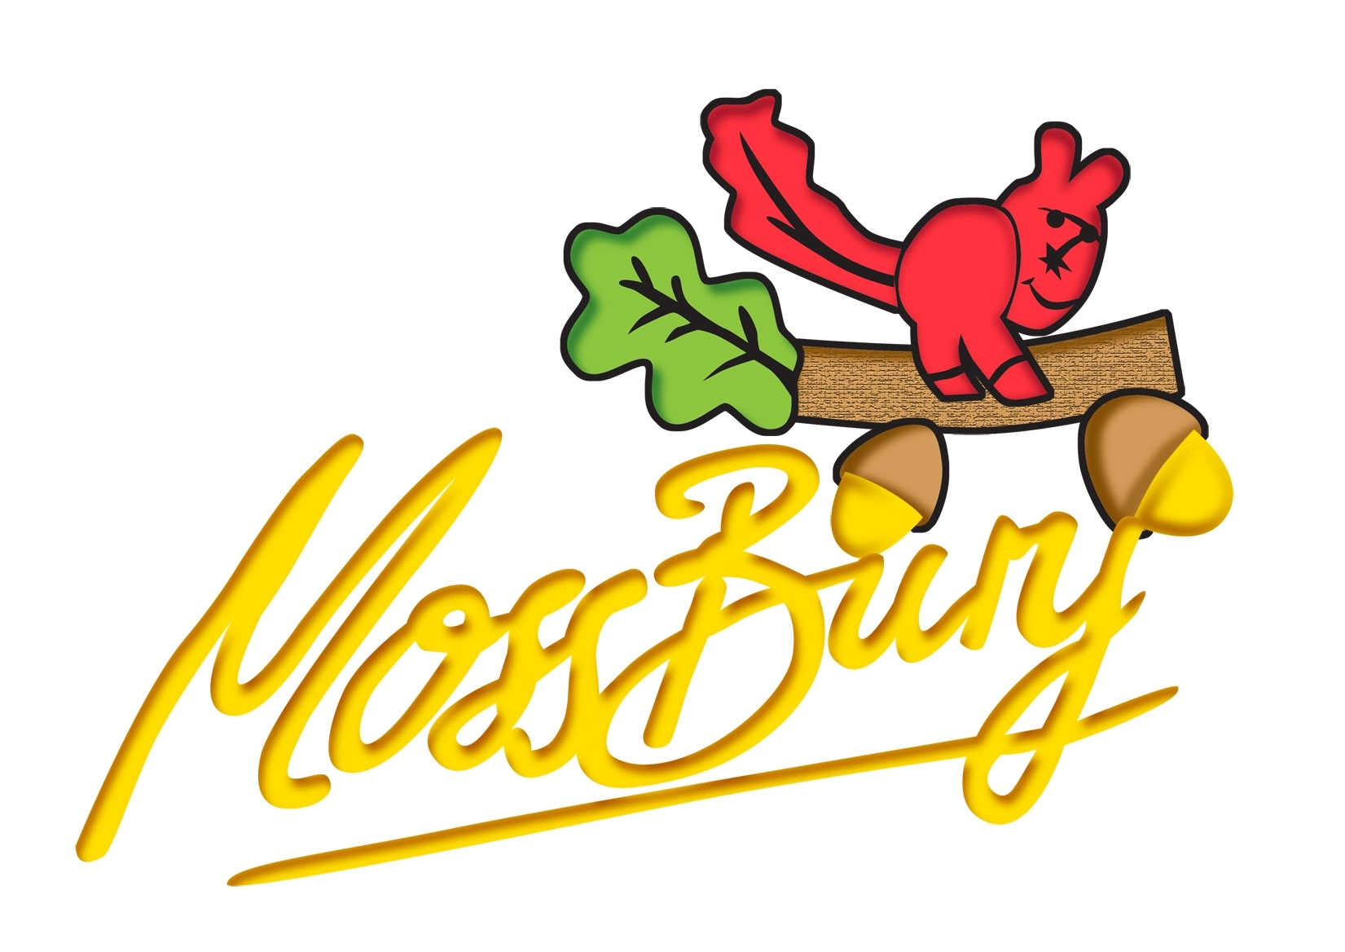
Webb Rise
Stevenage
Hertfordshire
SG1 5PA
Tel: 01438 222 300
e-Mail: admin@mossbury.herts.sch.uk
website: www.mossbury.herts.sch.uk

Co-Headteachers: Michael Dean & Callum Newbury
31st January 2023

Dear Parents,

We wanted to provide a final update regarding the plans for tomorrow. This follows the ‘Strike Action Update’ letter that was published on Thursday 26th January. Thank you to all that have helped us make this plan in advance of the day.

If your child(ren) are in Reception or Nursery, they will attend school as normal.

The children who have been allocated a place in the other year groups have now been contacted either by email or a telephone call. This email includes information about drop-off and collection. Please ensure that you have read this.

The school is not open for any other children.

Benefit-Related Free School Meals

If your child is entitled to benefit-related free school meals and your child is not attending for the day then you can still order to collect the meal. Tomorrow’s option is a cheese roll.
To order this, you need to email admin@mossbury.herts.sch.uk with the subject ‘Benefit-Related Free School Meal’. We will then have the lunch ready to collect at 12:30pm. You can enter the main gate to collect this.

Home Learning
We are pleased to direct parents to plenty of work that children can still complete at home, if required. We have provided some weblinks below:
- Firstly, Mossy Explorer!
- Oak National Academy has lessons browsable by subject and age. https://classroom.thenational.academy/
- Archived Home Learning on the Moss Bury website. Organised by year group, all of the home learning set during the pandemic remains online: https://www.mossbury.herts.sch.uk/kids-corner/archived-home-learning
- White Rose Maths. Our Mathematics Curriculum has an entire suite of home learning videos that can be independently accessed by children. Search by year group and use the New Scheme, and then click on the block for which you would like to see videos. All children have completed the Place Value and Addition and Subtraction blocks for the Autumn Term so revision of these would be extremely useful. Maths home learning | Home learning | White Rose Maths
Select the Year Group and choose the ‘new scheme’. You can then choose to revise Autumn term content or choose Spring Term content that is currently being taught in class.
- Hit The Button. Practice number facts (Early Years & Key Stage 1) or Times Tables and Division Facts (Key Stage 2): Hit the Button - Quick fire maths practise for 6-11 year olds (topmarks.co.uk)

There is no expectation that children complete this work, but those parents who are working at home may find these links useful.
Finally, thank you for your co-operation and understanding.

Yours sincerely,

Mr Newbury
Co-Headteacher

